**Assignement 1: Mitesh Sharma**

**___________________________________________________**

**Install VirtualBox**

**Install CentOS 7**

**Create a user as your first letter in the first name and last name.**

**Ex: Kranthi kavuri = kkavuri**

**Go to your home directory.**

**Create subdirectories in your home directory with your username + 1 & 2.**

**Create a file with your username.**

**Change the permissions for the file to read and write but not execute.**

**Change the permission for the file to read and execute but not write.**

**Write two lines in a file and display it to the screen.**

**______________________________________________________**

**Create user:**

useradd msharma

passwd msharma

**Create Dir:**

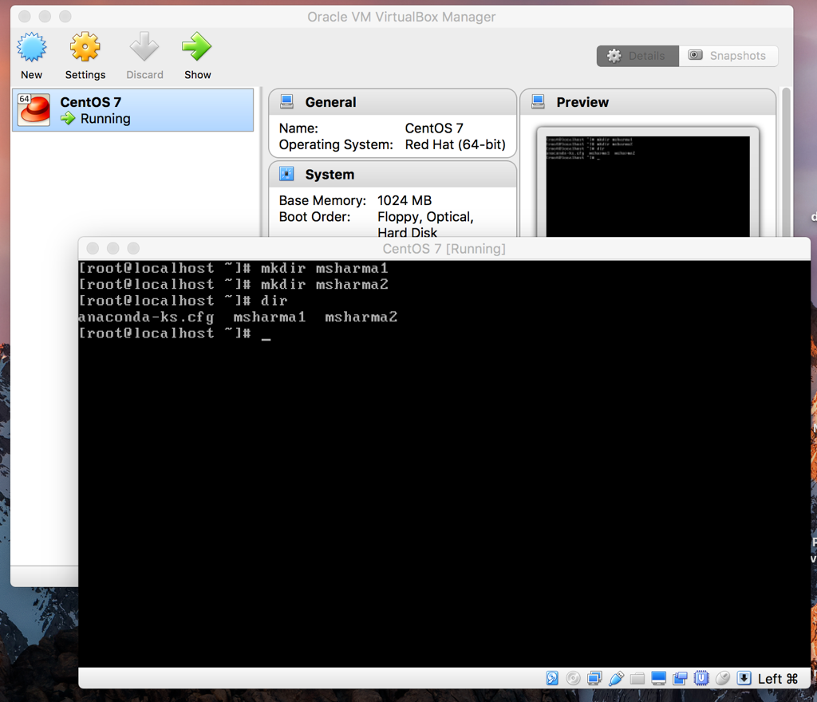

**Create File:**

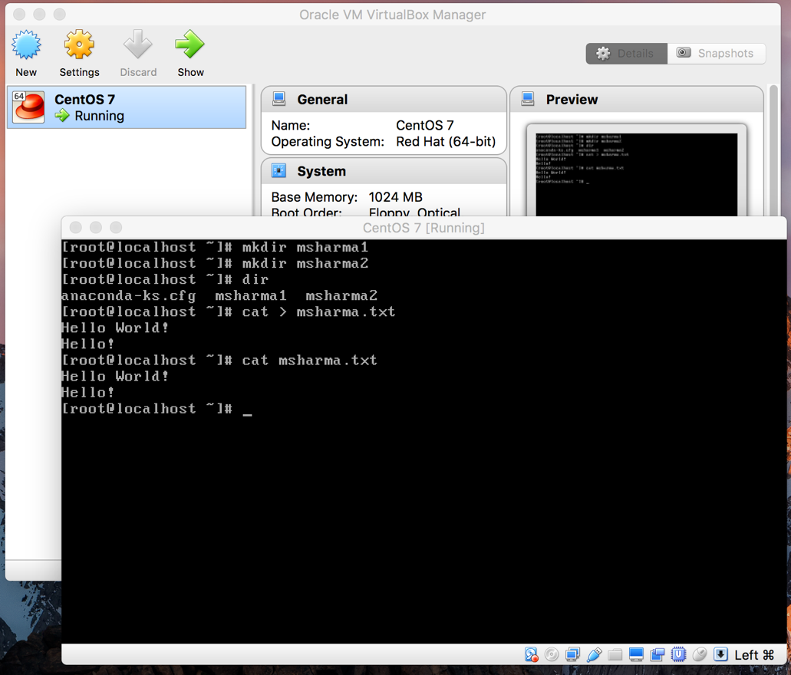

**Change File Permissions:**

